# Informações do estudo

Referência: Cakir (2)

Grandeza: Rugosidade

Tipo: Ra

Material: AISI P20

Ferramenta: CNMG 120408 2

Número de experimentos: 27

Observações:  
Workpiece: diameter of 70mm and a length of 300mm  
Lathe: 5.5kW

# Unidades

Velocidade: m/min

Avanço: mm/rev

Profundidade de corte: mm

Rugosidade: μm

# Dados de teste

|  |  |  |  |
| --- | --- | --- | --- |
| Rugosidade | n | f | a |
| 0.8 | 160.0 | 0.12 | 1.0 |
| 1.9 | 160.0 | 0.22 | 2.0 |
| 1.38 | 120.0 | 0.18 | 2.0 |
| 1.56 | 160.0 | 0.18 | 2.0 |
| 0.86 | 120.0 | 0.12 | 1.5 |
| 1.28 | 200.0 | 0.18 | 1.0 |

# Dados de treino

|  |  |  |  |
| --- | --- | --- | --- |
| Rugosidade | n | f | a |
| 1.88 | 200.0 | 0.22 | 2.0 |
| 1.32 | 200.0 | 0.18 | 1.5 |
| 1.68 | 160.0 | 0.22 | 1.0 |
| 1.72 | 160.0 | 0.22 | 1.5 |
| 1.55 | 160.0 | 0.18 | 1.5 |
| 0.79 | 200.0 | 0.12 | 1.5 |
| 1.27 | 120.0 | 0.18 | 1.5 |
| 2.23 | 120.0 | 0.22 | 2.0 |
| 1.98 | 120.0 | 0.22 | 1.5 |
| 0.98 | 120.0 | 0.12 | 2.0 |
| 0.89 | 160.0 | 0.12 | 1.5 |
| 0.83 | 200.0 | 0.12 | 2.0 |
| 1.57 | 200.0 | 0.22 | 1.0 |
| 1.11 | 120.0 | 0.18 | 1.0 |
| 0.94 | 160.0 | 0.12 | 2.0 |
| 1.84 | 120.0 | 0.22 | 1.0 |
| 0.82 | 120.0 | 0.12 | 1.0 |
| 0.69 | 200.0 | 0.12 | 1.0 |
| 1.78 | 200.0 | 0.22 | 1.5 |
| 1.51 | 200.0 | 0.18 | 2.0 |
| 1.29 | 160.0 | 0.18 | 1.0 |

# RN

Número de neurônios: 17

Taxa de aprendizado: 1.000000e-01

Número de épocas: 716

2° camada: True

Função de ativação: relu

# Erros

**Dados de teste**

* Erro relativo médio: 7.67
* Coeficiente de correlação: 0.97
* Coeficiente de determinação: 0.94
* MSE: 0.02
* RMSE: 0.14

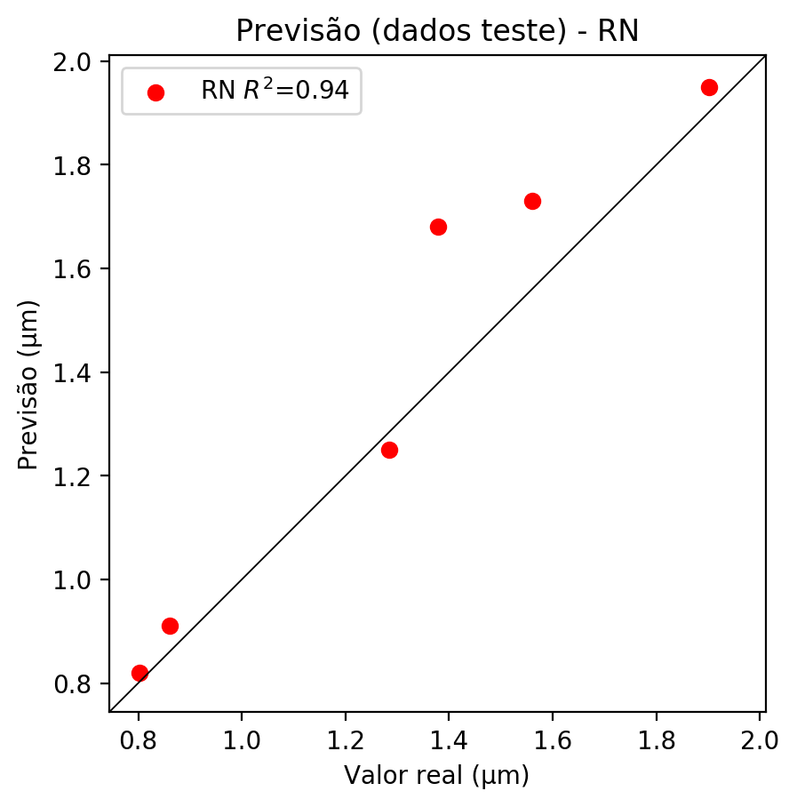

**Dados de treino**

* Erro relativo médio: 0.22
* Coeficiente de correlação: 1.0
* Coeficiente de determinação: 1.0
* MSE: 0.0
* RMSE: 0.0

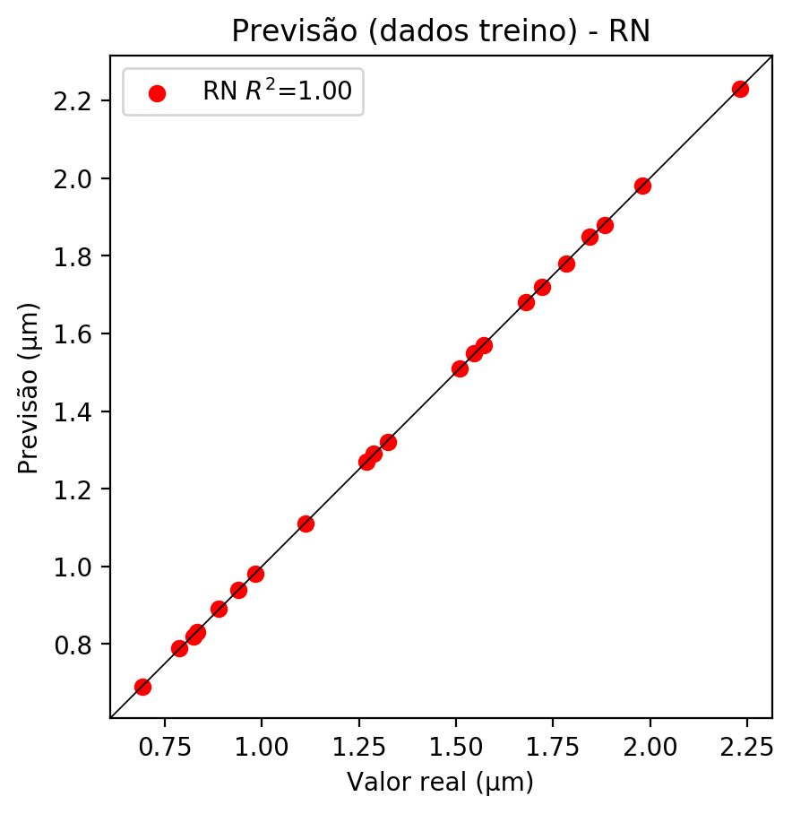

# Pesos

Pesos - camada oculta 1

[[-0.7470089 -0.58569425 -0.32376552 -0.46123433 -0.19333145 -0.0920108  
 -0.32478616 -0.79097897 -0.34193164 0.32870993 -0.25853434 0.11450308  
 -0.5541318 0.8386359 -0.80864435 0.7628835 0.3333481 ]  
 [ 0.49516895 -0.22173624 0.30133638 1.022646 -0.23387463 0.43010336  
 0.06363575 -0.60826206 -0.9006401 0.07075205 -0.4205149 0.7920286  
 -0.834827 -0.7564164 0.2594361 -0.35555694 -0.76393485]  
 [-0.14382192 -0.1320272 0.39607108 0.624583 0.18974206 0.42752495  
 0.6474978 0.17081493 -0.48225078 -0.2741698 0.2220955 -0.15754595  
 0.05460466 -0.5278906 0.25325906 0.44550592 0.34004584]]

Bias - camada oculta

[-0.67118233 -0.71902865 -0.5821212 0.27274176 -0.82104427 0.2484884  
 -0.5680449 -0.13748944 0.23686217 -1.1042683 -0.7841522 0.39270577  
 0.04602009 0.15715365 -0.32475764 0.24519432 -0.88604504]

Pesos - camada oculta 2

[[ 5.52925467e-01 9.02523100e-02 5.03009498e-01 -4.42830592e-01  
 -3.96200746e-01 -2.04533741e-01 7.36605048e-01 -6.55120373e-01  
 -7.41213024e-01 -4.40691978e-01 4.43176150e-01 -3.26738000e-01  
 -5.14809549e-01 2.67632067e-01 6.75472021e-01 -7.70544469e-01  
 -8.31561327e-01]  
 [-7.85167634e-01 -3.53642941e-01 1.05718982e+00 -1.95591420e-01  
 -3.07578474e-01 -5.99033415e-01 7.80147076e-01 -5.92183411e-01  
 -2.98601627e-01 -2.34631717e-01 7.78392076e-01 -2.88289785e-01  
 -9.24205780e-01 5.15547276e-01 2.49186739e-01 3.51493359e-01  
 -6.10320508e-01]  
 [ 7.67057300e-01 -8.91756535e-01 -3.12013119e-01 6.62886858e-01  
 -3.18291903e-01 -1.09748453e-01 -3.76501083e-01 4.03256357e-01  
 -2.47781470e-01 1.01179135e+00 -4.25731659e-01 -6.52545512e-01  
 6.08893812e-01 -8.67849469e-01 3.33848223e-02 -1.84405893e-01  
 9.03289139e-01]  
 [ 6.82059526e-01 -4.26633030e-01 -6.84934556e-01 -4.10595499e-02  
 5.54301858e-01 3.13744247e-02 -6.46822810e-01 -6.19834483e-01  
 -9.71866250e-01 5.76922596e-01 -9.38871026e-01 -9.19902444e-01  
 3.56565297e-01 -1.49646252e-01 -8.08389008e-01 -6.94650888e-01  
 2.53304392e-01]  
 [ 3.74252021e-01 -2.33528957e-01 5.44288643e-02 5.45856476e-01  
 7.35177398e-01 -3.04764509e-01 -6.72113419e-01 -5.43839693e-01  
 -4.59103644e-01 9.96847272e-01 -5.14583826e-01 -7.25656927e-01  
 9.61284816e-01 -9.09892380e-01 1.10887870e-01 -6.83044553e-01  
 4.52139288e-01]  
 [ 1.59014538e-01 -6.07827127e-01 -5.04189692e-02 -1.70820105e+00  
 -1.40767410e-01 -6.66210473e-01 -7.33008981e-01 -7.27611661e-01  
 -4.96502668e-01 -2.69671679e-01 3.20650637e-02 -1.00693476e+00  
 -1.93832383e-01 4.44270186e-02 9.16290432e-02 -4.16678071e-01  
 -2.23766565e-01]  
 [ 9.27950203e-01 -8.92618895e-01 -8.92455339e-01 3.68751734e-01  
 2.08007857e-01 -1.90742791e-01 -4.43105131e-01 5.60865283e-01  
 -6.08154118e-01 1.34603068e-01 -2.43154913e-01 -2.42683470e-01  
 6.24127865e-01 -4.07933056e-01 -2.87931800e-01 -7.54250109e-01  
 1.36876017e-01]  
 [-6.58382893e-01 -5.19144118e-01 -6.96322203e-01 -5.62446654e-01  
 -1.03289294e+00 -1.09819643e-01 -7.42288649e-01 -2.47770011e-01  
 -6.94861114e-01 -1.37537050e+00 -4.81122404e-01 -3.85342270e-01  
 -4.97692525e-01 -2.25588858e-01 9.54870433e-02 -1.98698148e-01  
 1.48975179e-01]  
 [-5.75983644e-01 -4.38200176e-01 -4.42095459e-01 -3.94480228e-01  
 -7.84369349e-01 -9.00031805e-01 -4.69975881e-02 -7.32601106e-01  
 -6.01506829e-01 -8.65142167e-01 4.71088558e-01 -4.06333387e-01  
 -1.10956721e-01 -2.44594105e-02 5.09247959e-01 -7.50465155e-01  
 -2.91374564e-01]  
 [ 2.59943575e-01 -2.76824027e-01 -4.22479719e-01 7.12283850e-01  
 8.92995715e-01 1.93540126e-01 -5.37803173e-01 -2.40319759e-01  
 -3.39949399e-01 1.45835951e-01 -6.43662989e-01 -9.10147667e-01  
 1.52577266e-01 -4.05299336e-01 -6.11770153e-01 -9.67036366e-01  
 2.06789196e-01]  
 [ 5.20972669e-01 -3.59844565e-01 -4.13908303e-01 7.33526289e-01  
 -1.02619457e+00 -3.30358118e-01 -1.10977089e+00 5.18126786e-01  
 -5.36986232e-01 2.43713185e-01 -2.45166391e-01 -3.35082442e-01  
 9.10817981e-01 -8.46250474e-01 -2.18834072e-01 -7.85749793e-01  
 8.69916379e-01]  
 [ 6.68994188e-01 -5.30288219e-02 -6.42436981e-01 2.14191526e-01  
 3.53742927e-01 -1.65034086e-01 -7.15436757e-01 -1.47583395e-01  
 -7.10282505e-01 3.99367094e-01 -5.21266639e-01 -1.67975754e-01  
 -1.91931516e-01 -2.17322141e-01 -3.37820858e-01 -1.99969351e-01  
 5.01070879e-02]  
 [-1.05950320e+00 -7.54632950e-01 1.08163171e-01 -6.53762817e-01  
 -6.16518378e-01 -2.15927273e-01 1.00771420e-01 -7.11926818e-01  
 -3.18493247e-01 -4.97415870e-01 3.96962285e-01 -4.92821604e-01  
 -2.55008698e-01 2.99788505e-01 5.91179371e-01 -3.92029464e-01  
 -2.15983819e-02]  
 [ 9.73346457e-03 -7.33008981e-01 5.73580563e-01 -2.23072067e-01  
 -8.38300765e-01 -5.62690377e-01 1.33793607e-01 3.84744555e-01  
 -9.29194689e-01 -1.10083246e+00 9.09364724e-04 -6.92046106e-01  
 1.90457001e-01 2.17964441e-01 7.45313704e-01 -7.66028225e-01  
 -8.48422796e-02]  
 [ 5.19802608e-03 -7.87216067e-01 -4.02462870e-01 -7.43588567e-01  
 -6.01689696e-01 -5.66508293e-01 -8.30027983e-02 -4.58872557e-01  
 -5.51393151e-01 -7.49432147e-01 3.01340729e-01 -5.55733144e-01  
 -2.22968221e-01 2.49770716e-01 4.91375566e-01 -6.58541143e-01  
 9.55643803e-02]  
 [ 6.73029348e-02 -2.53231317e-01 -3.91558945e-01 -6.12474501e-01  
 -9.10778224e-01 -7.22552180e-01 3.54947835e-01 -8.71195555e-01  
 -8.32763791e-01 -9.97369349e-01 -1.18409075e-01 -7.10692585e-01  
 -4.21350777e-01 -4.77438331e-01 3.65247875e-01 -3.53368521e-01  
 -2.04298228e-01]  
 [-9.06050801e-01 -1.00975764e+00 -5.13431013e-01 -5.59935689e-01  
 -4.52366412e-01 -7.48666823e-02 -1.43163241e-02 -6.96518898e-01  
 -6.32706702e-01 -2.69211441e-01 1.11680627e-02 -8.19398582e-01  
 -4.13696647e-01 7.62801945e-01 4.77212429e-01 -5.24983943e-01  
 -2.86124676e-01]]

Bias - camada oculta 2

[ 0.4402308 -0.60036606 -0.0353921 -0.43884215 -0.5488581 -0.5159596  
 -0.401432 -0.2588618 -0.60053873 -0.18147872 -0.7446205 -0.6005447  
 -0.01593488 -0.27193338 0.5611751 -0.63265777 0.08996771]

Pesos - camada saída

[[ 0.4573186 -0.47638366 -0.23941167 -0.28443664 -0.29286915 0.22530487  
 -0.05137014 0.37395364 0.40696615 -0.10695362 0.01638446 -0.22424479  
 -0.01353965 0.00778589 -0.34066084 0.37663248 0.07055046]]

# Iterações

|  |  |  |  |  |  |  |
| --- | --- | --- | --- | --- | --- | --- |
| Média | Desvio | n | ln | 2° camada | Função | Épocas |
| -0.1656 | 0.0712 | 10 | 0.1 | False | relu | 38 |
| -0.0718 | 0.0427 | 17 | 0.1 | True | relu | 716 |
| -0.1038 | 0.0919 | 7 | 0.01 | True | tanh | 130 |
| -0.1687 | 0.1352 | 19 | 0.001 | False | tanh | 282 |
| -0.1618 | 0.126 | 29 | 0.001 | False | relu | 469 |
| -0.2097 | 0.1684 | 88 | 0.1 | False | tanh | 926 |
| -0.1259 | 0.1056 | 95 | 0.0001 | True | relu | 984 |
| -0.1465 | 0.1526 | 10 | 0.01 | True | tanh | 865 |
| -0.7523 | 0.4286 | 58 | 0.001 | True | relu | 8 |
| -0.0851 | 0.0617 | 9 | 0.01 | False | tanh | 514 |
| -0.0997 | 0.0969 | 73 | 0.0001 | True | relu | 729 |
| -0.1696 | 0.1889 | 22 | 0.001 | True | relu | 543 |
| -0.1667 | 0.1302 | 25 | 0.1 | True | relu | 562 |
| -0.1366 | 0.1045 | 53 | 0.001 | False | relu | 498 |
| -0.1256 | 0.0768 | 83 | 0.01 | True | relu | 337 |
| -0.318 | 0.2755 | 99 | 0.01 | False | tanh | 16 |
| -0.1675 | 0.1293 | 23 | 0.01 | False | relu | 472 |
| -0.1905 | 0.1229 | 24 | 0.001 | True | relu | 778 |
| -0.1168 | 0.0416 | 58 | 0.01 | True | tanh | 382 |
| -0.1684 | 0.1112 | 35 | 0.1 | False | tanh | 596 |

# RL

# Coeficientes

[ 0. -0.12369357 0.96411406 0.28179586]

# Erros

**Dados de teste**

* Erro relativo médio: 8.05
* Coeficiente de correlação: 0.97
* Coeficiente de determinação: 0.94
* MSE: 0.02
* RMSE: 0.14

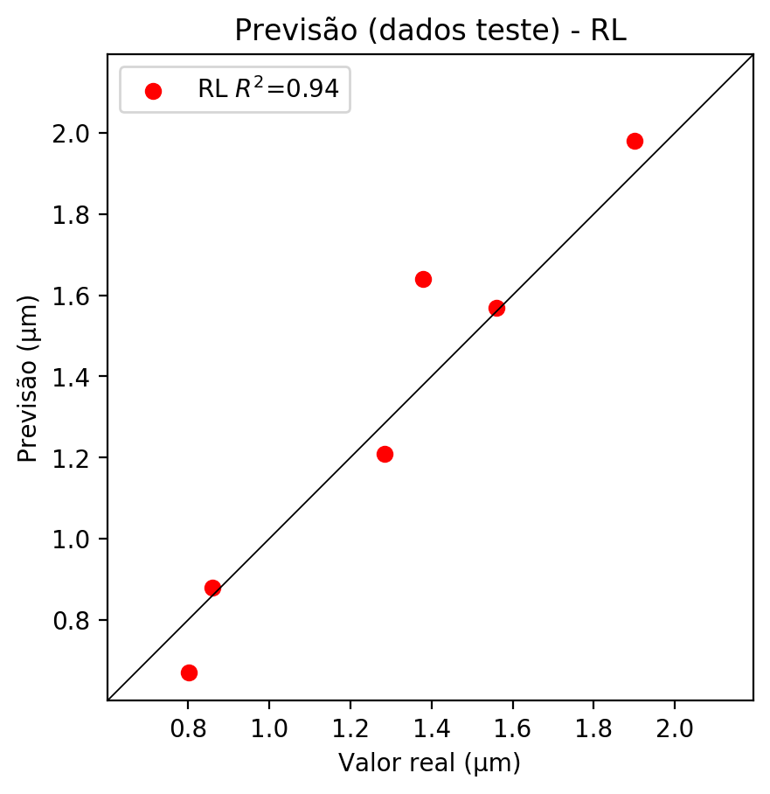

**Dados de treino**

* Erro relativo médio: 6.31
* Coeficiente de correlação: 0.97
* Coeficiente de determinação: 0.95
* MSE: 0.01
* RMSE: 0.1

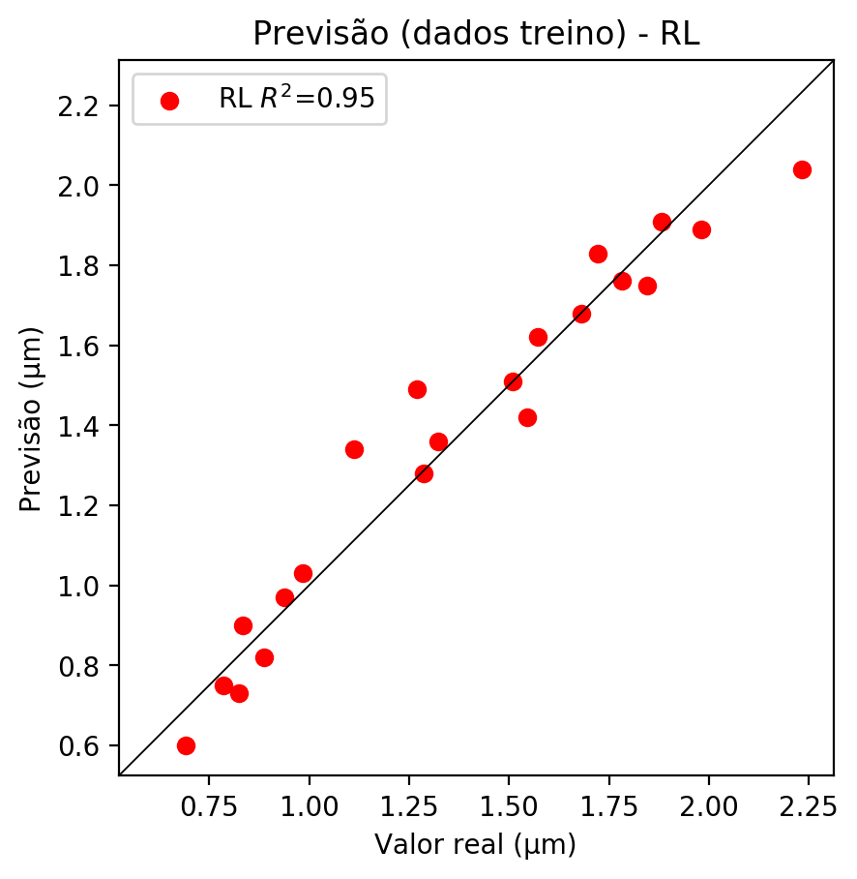

# RP2

# Coeficientes

[ 0. -0.1223601 0.99788546 0.28589673 -0.07279783 -0.05280553  
 -0.03350068 0.13198251 0.09500696 0.03257441]

# Erros

**Dados de teste**

* Erro relativo médio: 7.21
* Coeficiente de correlação: 0.97
* Coeficiente de determinação: 0.95
* MSE: 0.02
* RMSE: 0.14

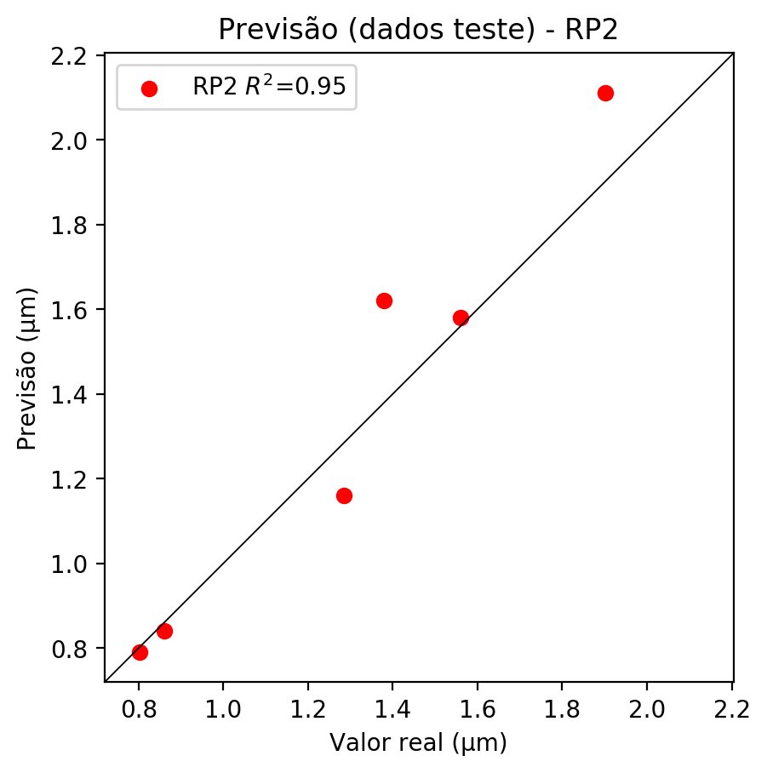

**Dados de treino**

* Erro relativo médio: 4.83
* Coeficiente de correlação: 0.98
* Coeficiente de determinação: 0.97
* MSE: 0.01
* RMSE: 0.1

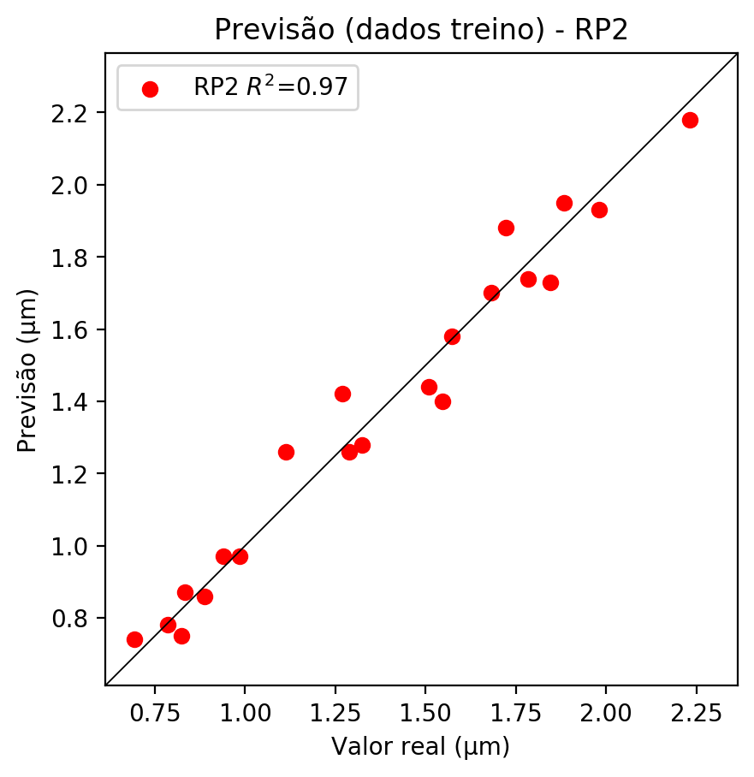

# RP3

# Coeficientes

[ 0. 0.02568983 0.27165177 0.073291 -0.06977892 -0.09354602  
 -0.03451507 0.12529232 0.07037225 0.04253167 0.03710753 0.15985551  
 0.13387981 -0.12190153 -0.01208386 -0.08551317 0.39238589 -0.12212327  
 -0.03829234 0.10586478]

# Erros

**Dados de teste**

* Erro relativo médio: 12.43
* Coeficiente de correlação: 0.91
* Coeficiente de determinação: 0.84
* MSE: 0.03
* RMSE: 0.17

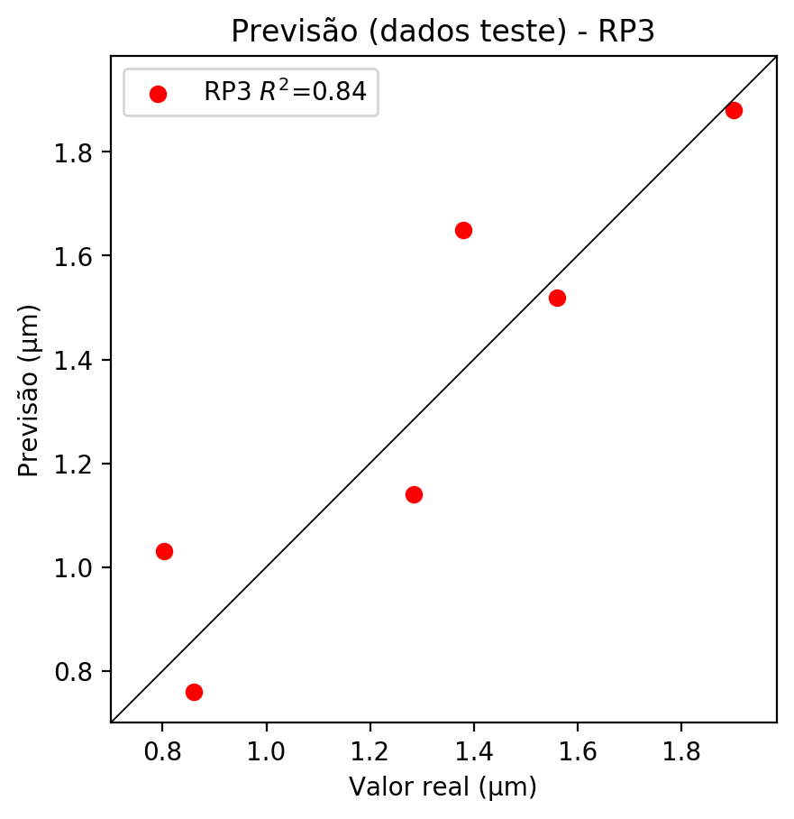

**Dados de treino**

* Erro relativo médio: 2.81
* Coeficiente de correlação: 0.99
* Coeficiente de determinação: 0.99
* MSE: 0.0
* RMSE: 0.0

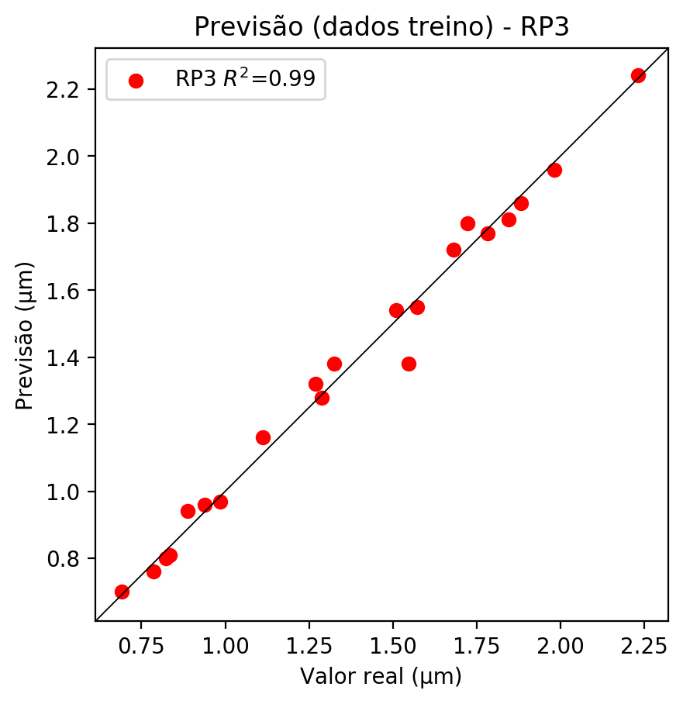

# RP4

# Coeficientes

[-3.32755226e-02 1.92063147e-04 2.43769656e-01 5.91711492e-02  
 -7.95672256e-02 -1.77196181e-02 5.92209240e-02 -9.41770257e-02  
 3.36754810e-03 -2.75065386e-02 4.30469200e-02 2.12396620e-01  
 1.24716067e-01 -1.34714696e-01 -3.07074128e-02 -6.57764264e-02  
 3.34224202e-01 -1.21297040e-01 5.29896778e-03 1.14406077e-01  
 -2.46156184e-01 -2.15390398e-02 3.80801261e-02 3.62735479e-01  
 1.09995377e-01 6.12980030e-02 -2.02743922e-02 -1.32826914e-01  
 -7.40880413e-03 3.80801261e-02 -1.16167929e-01 -4.60008194e-02  
 1.11996620e-01 -2.53683656e-02 -1.41530483e-01]

# Erros

**Dados de teste**

* Erro relativo médio: 9.74
* Coeficiente de correlação: 0.92
* Coeficiente de determinação: 0.84
* MSE: 0.04
* RMSE: 0.2

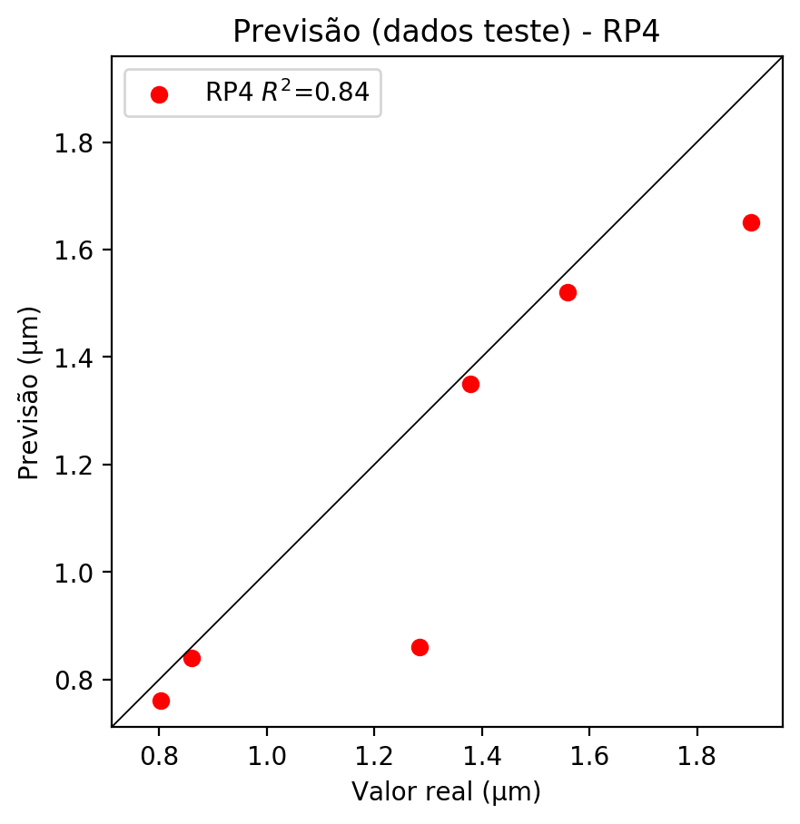

**Dados de treino**

* Erro relativo médio: 0.22
* Coeficiente de correlação: 1.0
* Coeficiente de determinação: 1.0
* MSE: 0.0
* RMSE: 0.0

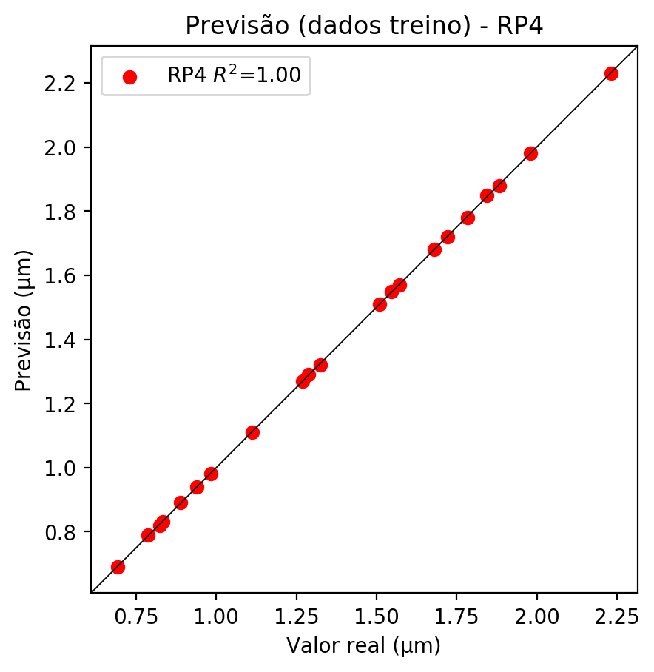

# Geral

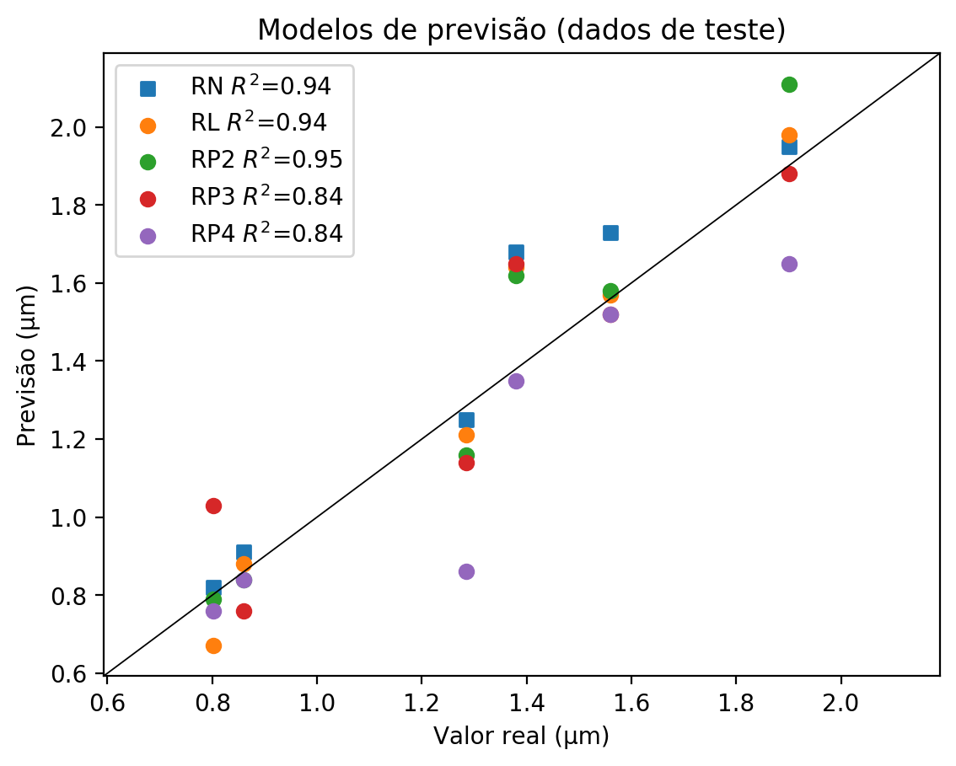

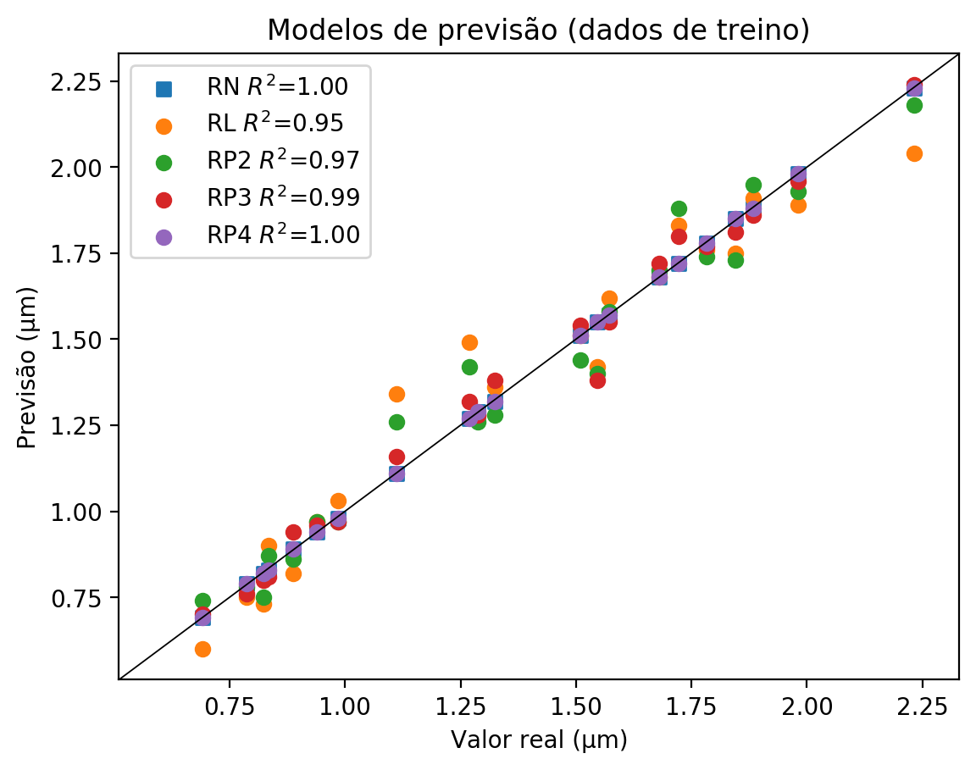

**Dados de teste**

|  |  |  |  |  |  |  |  |  |  |  |
| --- | --- | --- | --- | --- | --- | --- | --- | --- | --- | --- |
| Valor real | RN Previsto | RN Erro (%) | RL Previsto | RL Erro (%) | RP2 Previsto | RP2 Erro (%) | RP3 Previsto | RP3 Erro (%) | RP4 Previsto | RP4 Erro (%) |
| 0.8 | 0.82 | 2.24 | 0.67 | 16.46 | 0.79 | 1.5 | 1.03 | 28.43 | 0.76 | 5.24 |
| 1.9 | 1.95 | 2.58 | 1.98 | 4.16 | 2.11 | 10.99 | 1.88 | 1.1 | 1.65 | 13.2 |
| 1.38 | 1.68 | 21.83 | 1.64 | 18.93 | 1.62 | 17.48 | 1.65 | 19.65 | 1.35 | 2.1 |
| 1.56 | 1.73 | 10.9 | 1.57 | 0.64 | 1.58 | 1.28 | 1.52 | 2.56 | 1.52 | 2.56 |
| 0.86 | 0.91 | 5.81 | 0.88 | 2.33 | 0.84 | 2.33 | 0.76 | 11.63 | 0.84 | 2.33 |
| 1.28 | 1.25 | 2.65 | 1.21 | 5.76 | 1.16 | 9.66 | 1.14 | 11.21 | 0.86 | 33.02 |

**Dados de treino**

|  |  |  |  |  |  |  |  |  |  |  |
| --- | --- | --- | --- | --- | --- | --- | --- | --- | --- | --- |
| Valor real | RN Previsto | RN Erro (%) | RL Previsto | RL Erro (%) | RP2 Previsto | RP2 Erro (%) | RP3 Previsto | RP3 Erro (%) | RP4 Previsto | RP4 Erro (%) |
| 1.88 | 1.88 | 0.16 | 1.91 | 1.43 | 1.95 | 3.56 | 1.86 | 1.22 | 1.88 | 0.16 |
| 1.32 | 1.32 | 0.3 | 1.36 | 2.72 | 1.28 | 3.32 | 1.38 | 4.23 | 1.32 | 0.3 |
| 1.68 | 1.68 | 0.06 | 1.68 | 0.06 | 1.7 | 1.13 | 1.72 | 2.32 | 1.68 | 0.06 |
| 1.72 | 1.72 | 0.12 | 1.83 | 6.27 | 1.88 | 9.18 | 1.8 | 4.53 | 1.72 | 0.12 |
| 1.55 | 1.55 | 0.26 | 1.42 | 8.15 | 1.4 | 9.44 | 1.38 | 10.74 | 1.55 | 0.26 |
| 0.79 | 0.79 | 0.51 | 0.75 | 4.58 | 0.78 | 0.76 | 0.76 | 3.31 | 0.79 | 0.51 |
| 1.27 | 1.27 | 0.0 | 1.49 | 17.32 | 1.42 | 11.81 | 1.32 | 3.94 | 1.27 | 0.0 |
| 2.23 | 2.23 | 0.09 | 2.04 | 8.6 | 2.18 | 2.33 | 2.24 | 0.36 | 2.23 | 0.09 |
| 1.98 | 1.98 | 0.05 | 1.89 | 4.59 | 1.93 | 2.57 | 1.96 | 1.06 | 1.98 | 0.05 |
| 0.98 | 0.98 | 0.41 | 1.03 | 4.67 | 0.97 | 1.42 | 0.97 | 1.42 | 0.98 | 0.41 |
| 0.89 | 0.89 | 0.23 | 0.82 | 7.66 | 0.86 | 3.15 | 0.94 | 5.86 | 0.89 | 0.23 |
| 0.83 | 0.83 | 0.48 | 0.9 | 7.91 | 0.87 | 4.32 | 0.81 | 2.88 | 0.83 | 0.48 |
| 1.57 | 1.57 | 0.13 | 1.62 | 3.05 | 1.58 | 0.51 | 1.55 | 1.4 | 1.57 | 0.13 |
| 1.11 | 1.11 | 0.18 | 1.34 | 20.5 | 1.26 | 13.31 | 1.16 | 4.32 | 1.11 | 0.18 |
| 0.94 | 0.94 | 0.11 | 0.97 | 3.3 | 0.97 | 3.3 | 0.96 | 2.24 | 0.94 | 0.11 |
| 1.84 | 1.85 | 0.27 | 1.75 | 5.15 | 1.73 | 6.23 | 1.81 | 1.9 | 1.85 | 0.27 |
| 0.82 | 0.82 | 0.49 | 0.73 | 11.41 | 0.75 | 8.98 | 0.8 | 2.91 | 0.82 | 0.49 |
| 0.69 | 0.69 | 0.29 | 0.6 | 13.29 | 0.74 | 6.94 | 0.7 | 1.16 | 0.69 | 0.29 |
| 1.78 | 1.78 | 0.17 | 1.76 | 1.29 | 1.74 | 2.41 | 1.77 | 0.73 | 1.78 | 0.17 |
| 1.51 | 1.51 | 0.07 | 1.51 | 0.07 | 1.44 | 4.57 | 1.54 | 2.05 | 1.51 | 0.07 |
| 1.29 | 1.29 | 0.23 | 1.28 | 0.54 | 1.26 | 2.1 | 1.28 | 0.54 | 1.29 | 0.23 |